A PROJECT REPORT
ON
“INTERNET CAFÉ SUITE”

Submitted In The Partial Fulfillment For The Award Of Degree Of

BACHELOR OF ENGINEERING

IN

COMPUTER SCIENCE AND ENGINEERING

From

Pt. RAVISHANKAR SHUKLA UNIVERSITY, RAIPUR
(CHHATTISGARH)

Submitted by: Guided by:
Sameer A Vachhani Mr. Dinesh Kumar Bhawnani
Sameer kumar Dash Lecturer
Sandeep Vijay Kharche Dept. Of CSE
Siddhesh Bade


SESSION 2004 - 2008

DEPARTMENT OF computer science and engineering
BHILAI INSTITUTE OF TECHNOLOGY
BHILAI HOUSE, DURG, Chhattisgarh - 491001.

Bhilai Institute of Technology
Bhilai house, Durg (C.G) 491001

CERTIFICATE OF PROJECT COMPLETION

This is to certify that Sameer A Vachhani , Sameer Kumar Dash , Sandeep Vijay Kharche and Siddhesh Bade are bonafide students of B.E. 8TH SEM in the Department of COMPUTER SCIENCE AND ENGINEERING at Bhilai Institute of Technology, Durg, Chhattisgarh, and have worked under my guidance and supervision on the project entitled: INTERNET CAFÉ SUITE for the award of the Degree of Bachelor of Engineering from Bhilai Institute of Technology affiliated to Pt. Ravi Shankar Shukla University, Raipur (C.G.)

While forwarding the project work and report on the topic mentioned above, I certify that they have completed their project work under prescribed period and the project work incorporated the result of the job done by them during this period.

Guided By:
Mr Dinesh Kumar Bhawnani
Lecturer
Deptt. Of Comp. Sc.
BIT, Durg
Project in charge:
Mr. SHANKHA DE
Lecturer
Deptt. Of Comp. Sc.
BIT, Durg

Bhilai Institute of Technology
Bhilai house, Durg (C.G) 491001

Recommendation

We are pleased to recommend the project work submitted by
Sameer A Vachhani
Sameer Kumar Dash
Sandeep Vijay Kharche
Siddhesh Bade.

entitled

INTERNET CAFÉ SUITE
Completed in session 2007-2008 for the acceptance as

Prerequisite to the degree of the Bachelor of Engineering in

“Computer Science and Engineering”

Guided By: Approved By:
Mr. Dinesh Kumar Bhawnani Mr. RAMESH KUMAR
Lecturer Head of Department
Deptt. Of Comp. Sc. Deptt. Of C.S.E

Bhilai Institute of Technology
Bhilai house, Durg (C.G) 491001

CERTIFICATE

This is to certify that the project work entitled

”INTERNET CAFÉ SUITE”

Carried out by Sameer A Vachhani , Sameer Kumar Dash , Sandeep Vijay Kharche and Siddhesh Bade is hereby approved as a creditable work for the partial fulfillment of the requirement for awarding the degree of Bachelor of Engineering in “Computer Science & Engineering “.

Internal Examiner External Examiner

Date: Date:

Bhilai Institute of Technology
Bhilai house, Durg (C.G) 491001

ACKNOWLEDGEMENT

Working on this project has been a great learning experience for us. There were moments of anxiety, when we could not solve a problem for several days & there were moments when we could solve a problem after struggling for several days. But we have enjoyed every bit of the process and are thankful to all people associated with us during this period.
We convey our sincere thanks to our project guide Mr.Dinesh Kumar Bhawnani, for providing us all sorts of facilities. His support & guidance helped us to carry out the project. I owe a great debt of his gratitude for his constant advice, support, cooperation & encouragement throughout the project.
We would also like to express our deep gratitude to Mr. Ramesh Kumar for his ever helping and support. We also pay special thanks for his helpful solution & comments enriched by his experience, which improved our ideas for the betterment of project.
It will be our pleasure to acknowledge, utmost co-operation & valuable suggestion from time to time given by other staff members of Department, to whom we owe our entire computer knowledge and also we would like to thank all those persons who have directly or indirectly helped us by providing books & computer peripherals and other necessary amenities which helped in the development of this project which would otherwise have not been possible.

SUBMITTED BY:
Sameer A Vachhani
Sameer Kumar Dash
Sandeep Vijay Kharche
Siddhesh Bade

INDEX

CHAPTERS PAGE

ABSTRACT 7

CHAPTER - 1 Feasibility Study 9
  - Problem Statement 10
1.2 Scope 19

CHAPTER - 2 Requirement Specifications 20
  - Requirement Analysis 21
  - Planning 22
    - Life Cycle Model 22
    - Software Metrics 23
2.2.3 Project Scheduling 25
2.3 Software Requirement Specification 26

CHAPTER - 3 Design 27
3.1 Data flow diagram 28

CHAPTER - 4 Implementation 45
  - Programming Approach 46
  - Coding Of Key Interfaces 47

CHAPTER - 5 Testing 62
  - Testing Strategy 63
  - Test Plan 65
  - Test Cases 69
  - Test Result Documentation 66

CHAPTER - 6 Conclusions 75
6.1 Advantages 76
6.2 Limitations 79
6.3 Future Enhancements 79
6.4 References 79

ABSTRACT

INTERNET CAFÉ SUITE

This is a client/server based application software in which two programs will be there one will be installed on the client side and other will be on server side. This program on the server side will control all the functions of the terminals or PC’s on the client side. This application will be used to monitor and control strategy for client side program.

Now a days every thing is becoming automated using computers and the working of the systems is made very easy. Adding to it our software will help the internet cafes to easily manage various aspects of a good internet café very quickly and efficiently. Normally in an internet café manual management of the resources and customer’s time of usage is done. Now all above it daily earning reports, shutting down and restarting terminals remotely, website monitoring are some of the robust features of our project.

Technically speaking our project works on a TCP/IP protocol which is a more reliable and robust networking protocol. Our application automatically detects all client PC’s connected over the Local Area Network and dedicatedly manages all the terminals very efficiently.

From the future point of view our project is very much compatible with the latest trends of the retail marketing and malls. A big internet café will always prefer our application as their need in contrast with the changing world.

Chapter – 1

FEASIBILITY STUDY

1.1 Problem Statement

Some of the common problems faced by cyber (internet) café managers could be maintaining a log of time and manual calculation of billing of all the customers. Let’s take a small example: Imagine you are running a café comprising 10 computers and you run your café 10 hours a day, and the average turnover time per customer is 1 hour. That means you would have to handle 100 customers in a day. Maintaining a time log and manual calculation of the billing can entirely be a cumbersome process even for the highly efficient on a daily basis. Things would be compounded if your café is bigger or you have expansion plans.

Technical Problems:
Some Technical Problems like some one has formatted my hard disk and I had to waste the whole day plus pay 500 rupees for getting back my machine. Some one deleted windows system files and I had to sit and re-install windows.
Solution:
Internet Café Suite enables you to restrict access of the customer to the PC. You make all the rules and everyone has to follow them. You decide what level of access you want to provide to the customer. Restrict customers’ access to browsing only. No one can fiddle around with your systems.

Regulating Web Surfing:
People come and regularly download files and choke up my machine; I want a way to restrict people from downloading files from internet. I want to ban surfers from visiting X sites, but to do this I have to keep watch on them or purchase ban software and to use that I have to enter names of each website.I want to know who visited which websites, so that I can help police if they are hunting for some suspect.
Solution:
Internet Café Suit does it all for you. The powerful features of Internet Café Suit is that it enables you to manage and review all the content being surfed in our café. You can restrict all downloads, ban X sites by using Banned Keyword Master, maintain separate log of every customer.

Billing Activity:
I think my employee, who sits in cyber cafe does not tell me the exact money collected through out the day and steals away some money from daily collection I want to know how many times printouts were taken in a day I want to give printout of the bill to customer? I wish to offer service like tea, coffee, printing etc in my cyber cafe and want my cyber cafe management software to handle it.
Solution:
You can monitor and manage all your business transaction activity. Our software keeps a record of each and every activity of customer in the café. Billing amount is automatically calculated including surfing time, number of printouts, facilitation of floppy, additional billing depending on tea, coffee, and snacks etc. ordered

Business Management and Efficiency:
I want to easily manage Walk-in Post Paid customers and Members Pre Paid Customers
I want to manage members’ accounts on the fly, and even offer them services from their member account I want to manage and have different time slots like Happy Hours, Peak Hours in my cyber cafe but want my cyber cafe software to do this so that I don't have to worry how many minutes customer sat in which time slot. I don't know how much time in day my machines are occupied and how much time they are actually free.
Solution :
Manage all your business operations with ease. Manage all your member accounts and walk in customers. You can set Internet Café Suite to different rate and slot cycles. Get reports of all you business operations. Analyze how your business is performing, what time of day is the occupancy rate is high and when is it low. This will help you in deciding on Peak Hours and Happy Hours.
This is where Internet Café Suite or the Internet Billing software can assist you. Apart from weeding out these fundamental problems Internet Café Suite comes along with a variety of features which would make your day to day operations as easy as ever. After careful analysis of the cyber (internet) café market needs, Internet Café Suite introduced advanced features in the software, which can handle all of your problems. Below given are some of the common problems tacked by Internet Café Suite. We suggest you to download the evaluation copy to experience a new learning experience altogether.
Internet Café Suite ensures internet cafe staff accountability and system security with minimal interference to the cyber cafe customers thus resulting in smooth control. Reports are easy to view and understand, offering the cyber cafe owner a definite edge over the competing internet cafes.

• SERVER SIDE APPLICATION.
Here the owner or the main operator of the café is present who controls all the terminals using this application. The major features which the server side application deals are.

Management and Monitoring Features
• Point of Sale System
Using our easy to use and very flexible POS you can sell any items you offer. POS allows you to keep track of the inventory and can calculate the cost of items that you add to stock.

• Timing Control
Know exactly for how long customers use your computers.

• Receipt Setup
- Adjust the size of receipts to fit your printer.
- All receipts are numbered to allow checking or reprinting them.
- Show Cafe's Name, Date, Time, Employee, Receipt Number, Location and other info on each receipt.

• Reports
Check out earnings using automatically generated financial reports. You can see the total amount earned over a period of time and see when, on what computer, and with which administrator each cent was gained. Detailed statistics are generated using Microsoft Excel. They show how much money was gained during each our of the day, number of customers per hour and much more.

• Pricing
- Scheduled Pricing: you can have only one rate per hour or multiple rates per hour throughout a day. You can also specify a minimum or initial charge for a session.
- Bulk pricing: use this pricing mode if you want the price to change as time elapses. It allows you to charge more the person who comes in for a short period of time comparing to one who spends more time searching the net.

• Three Modes of Using Computers:
- Postpaid: customers can use cafe's services and pay afterwards.
- Prepaid session: administrator charges a customer and starts the session. This is a very easy operation.
- Prepaid Accounts: You can create member accounts with money amounts for your customers.

• Print Monitoring
Our application can control and charge for printing in postpaid and prepaid modes. You can choose whether to track each one of your printers. You can also specify different rates for Color and B&W pages. Our Application can control printing on network, shared and local printers.

• Computer Grouping
You can group computers into as many groups as you want. For example, you can have Ordinary, VIP, Gaming, and other groups. Each group has its own pricing for all 4 modes.

Complete Remote Control over CL Clients from CL Server
• Remote Client Setup
Set up all settings of CL Clients remotely from the Server.

• Remote Client Applications Setup
In Server, you can easily specify the list of applications and games available to use by your customers. In addition to program icons, you can also specify website shortcuts to be displayed by Clients.

• Transfer Sessions
Transfer sessions between Clients with a click of a button.
• Customize the Title of Internet Explorer
Specify your own title of Internet Explorer windows. Ex. "Microsoft Internet Explorer provided by our software."

• Message System
Customers can send messages to Server.

• Beginning of Session Options
Choose what happens if an customer starts a session. There are several options: session will be put on hold if a client computer is not connected; session will start after a period of time, after user's confirmation or immediately. If a customer starts a session in Client, these options are ignored.

• End of Session Options
Choose what happens to a client machine at the end of each session. There are several options: lock the computer, reboot, or lock for 2 min. and then reboot. The last option gives a customer enough time to decide whether to continue the session.

• Shutdown All Unused Computers
At day end, you can shutdown all computers from Server with a click of a button. You can also shutdown individual computers from Server.

• Reboot All Unused Computers
You can reboot all computers from Server with a click of a button. You can also reboot individual computers from Server.

• End Session from the Server (for all usage modes)
If a customer forgets to end the session, we can do it from Server

Client side application

In this side of application all the controls specified above are managed properly. Check out earnings using automatically generated financial reports. You can see the total amount earned over a period of time and see when, on what computer, and with which administrator each cent was gained. Detailed statistics are generated using Microsoft Excel. They show how much money was gained during each our of the day, number of customers per hour and much more.

• Pricing
- Scheduled Pricing: you can have only one rate per hour or multiple rates per hour throughout a day. You can also specify a minimum or initial charge for a session.
-Bulk pricing: use this pricing mode if you want the price to change as time elapses. It allows you to charge more the person who comes in for a short period of time comparing to one who spends more time searching the net.

• Three Modes of Using Computers:
- Postpaid: customers can use cafe's services and pay afterwards.
- Prepaid session: administrator charges a customer and starts the session. This is a very easy operation.
- Prepaid Accounts: You can create member accounts with money amounts for your customers.

• Print Monitoring
Our application can control and charge for printing in postpaid and prepaid modes. You can choose whether to track each one of your printers. You can also specify different rates for Color and B&W pages. Our Application can control printing on network, shared and local printers.

• Computer Grouping
You can group computers into as many groups as you want. For example, you can have Ordinary, VIP, Gaming, and other groups. Each group has its own pricing for all 4 modes.
Complete Remote Control over CL Clients from CL Server

• Remote Client Setup
Set up all settings of CL Clients remotely from the Server.

• Remote Client Applications Setup
In Server, you can easily specify the list of applications and games available to use by your customers. In addition to program icons, you can also specify website shortcuts to be displayed by Clients.

• Transfer Sessions
Transfer sessions between Clients with a click of a button.

• Customize the Title of Internet Explorer
Specify your own title of Internet Explorer windows. Ex. "Microsoft Internet Explorer provided by Cyberia cafe."

• Message System
Customers can send messages to Server.

• Beginning of Session Options
Choose what happens if an customer starts a session. There are several options: session will be put on hold if a client computer is not connected; session will start after a period of time, after user's confirmation or immediately. If a customer starts a session in Client, these options are ignored.

• End of Session Options
Choose what happens to a client machine at the end of each session. There are several options: lock the computer, reboot, or lock for 2 min. and then reboot. The last option gives a customer enough time to decide whether to continue the session.
• Shutdown All Unused Computers
At day end, you can shutdown all computers from Server with a click of a button. You can also shutdown individual computers from Server.

• Reboot All Unused Computers
You can reboot all computers from Server with a click of a button. You can also reboot individual computers from Server.

• End Session from the Server (for all usage modes)
If a customer forgets to end the session, we can do it from Server

Internet Café Suite is a premier Cybercafé Management software to manage your chain of cybercafés. Internet Café Suite provides you a complete automated solution for your day-to-day operations. You will be able to provide better service to your customers and manage your daily cash flow (You can check your earnings at any time of the day, week, month).

1.2 SCOPE

Internet Café Suite is technically sophisticated yet simple cyber cafe software to use. You can see that the features list of this superior cybercafé software is truly impressive. Employ this internet cafe software and gain total control over your cyber cafe operations.

Internet Café Suite has two user interfaces. One is the Server (Administrator) module and other is the Client Module. Internet Café Suite is compatible with Windows 98, ME, NT, 2K, XP. Using our easy to use software an Internet Café owner can very well manage his all types of transactions and business control activities keeping in mind the privacy and customer reliability. We have developed this software keeping in mind the future growth of retail industry i.e. shopping malls and shopping complexes where the requirement of such kind of softwares will become a compulsion.

Chapter – 2

REQUIREMENT ANALYSIS
AND SPECIFICATION

Requirement specification

REQUIREMENT ANALYSIS::

HARDWARE REQUIREMENTS ::
128 MB RAM
Processor 800 Mhz
100 MB free HDD space (Server Side)
50 MB free HDD space (Client side)
PC’s connected over LAN (atleast one server and one client)

SOFTWARE REQUIREMENTS ::
OS :- Windows XP SP2
Microsoft .NET Framework 2.0
PLATFORM :- Visual Basic 2005

Our H/W requirement is based on the OS which is installed on the server and client. And our S/W requirement is based on the development of the system.

PLANNING ::

LIFECYCLE MODEL ::
Lifecycle model basically deals with the development of the system and the phases through which the system undergoes. It tells the overall behaviour of the system.
The model which we are going to use in our development is
PROTOTYPE MODEL.
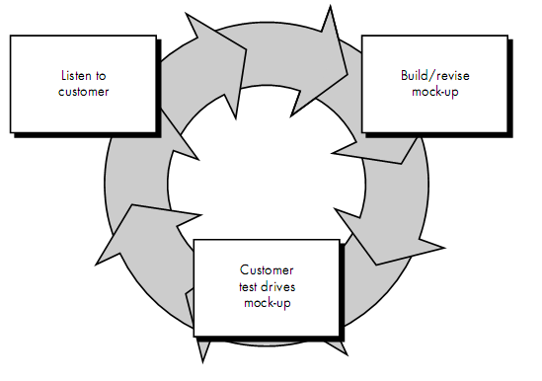

Developer and customer meet and define the overall objectives for the software, identify whatever requirements are known, and outline areas where further definition is
mandatory. A "quick design" then occurs. The quick design focuses on a representation of those aspects of the software that will be visible to the customer/user (e.g., input approaches and output formats). The quick design leads to the construction of a prototype. The prototype is evaluated by the customer/user and used to refine
requirements for the software to be developed. Iteration occurs as the prototype is
tuned to satisfy the needs of the customer, while at the same time enabling the developer to better understand what needs to be done.
Ideally, the prototype serves as a mechanism for identifying software requirements.If a working prototype is built, the developer attempts to use existing program fragments or applies tools (e.g., report generators, window managers) that enable working programs to be generated quickly.

SOFTWARE METRICS ::

FUNCTION POINTS ::

WEIGHING FACTORS
MEASUREMENT PARAMETER | COUNT |  | SIMPLE | AVERAGE | COMPLEX
No. of User Inputs | 15 | X | 3 | 4 | 6 | = | 60
No. of User Outputs | 10 | X | 4 | 5 | 7 | = | 50
No. of User Inquiries | 9 | X | 3 | 4 | 6 | = | 36
No. of Files | 20 | X | 7 | 10 | 15 | = | 200
No. of external interfaces | 1 | X | 5 | 7 | 10 | = | 7
Count Total = 353

Number of user inputs. Each user input that provides distinct application oriented data to the software is counted. Inputs should be distinguished from inquiries, which are counted separately.
Number of user outputs. Each user output that provides application oriented information to the user is counted. In this context output refers to reports, screens, error messages, etc. Individual data items within a report are not counted separately.
Number of user inquiries. An inquiry is defined as an on-line input that results in the generation of some immediate software response in the form of an online output. Each distinct inquiry is counted.
Number of files. Each logical master file (i.e., a logical grouping of data that may be one part of a large database or a separate file) is counted.
Number of external interfaces. All machine readable interfaces (e.g., datafiles on storage media) that are used to transmit information to another system are counted.

Now calculating Function Point.

FP= Count Total * [0.65 + 0.01* ∑Fi]

FP= 353 * [0.65 + 0.01*11]

FP= 268.28

COCOMO MODEL

As according to the requirement specified our project is of Organic Category. The following estimates have been done related to the no. of lines of code, effort and development time required in development.

Coefficients & exponents used in the Basic ( _b ) COCOMO Model
Software project type | a_b | b_b | c_b | d_b
Organic | 2.4 | 1.05 | 2.5 | 0.38
Semi-detached | 3.0 | 1.12 | 2.5 | 0.35
Embedded | 3.6 | 1.20 | 2.5 | 0.32

Now Approximate lines of code= 3000

E= a_b * ( KLOC ) b_b
=2.4 * (3000)1.05
=10744.56
D= c_b * ( E ) d_b
= 2.5*(10744.56).38
= 85
Where E – effort applied by per person per month, D – development time in consecutive months, KLOC – estimated thousands of lines of code delivered for the project.

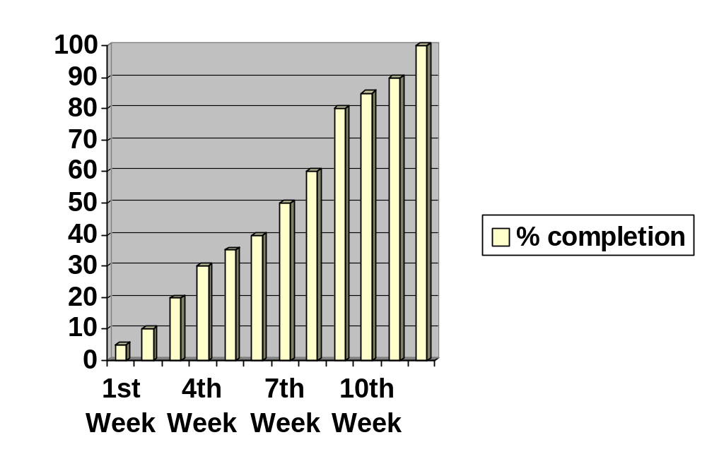PROJECT SCHEDULING

We have completed our analysis part and submitted on 24th of JAN means in 2 weeks. Now on 29th of JAN we have completed our requirement specification and submitted. The above chart shows the approximate completion of the project within 12 weeks.

Software Requirement Specification(SRS) or Software Requirement Plan(SRP) :-
It contains the following elements –

Goals :-
To completely manage all the terminals in an internet café.

Information description :-
Now our software will maintain all the above problems automatically by itself and notify the owner regarding the activities being performed at each and every terminal. Management regarding scheduling, log maintenance, receipt generation, printing, data sharing, terminal numbering, domain filtering is done.

Behavioral description :-
Our application will deal with server/client architecture. According to our H/W requirement the Server or Client should be there for proper working of the application. Here Server performs some tasks like session control, print monitoring and total automatic scheduling and receipt generation. Proper S/W should be present in the Client or Server side for proper execution.

Chapter – 3

DESIGN

DATA FLOW DIAGRAMS

0 – LEVEL DFD
Here only the overview of the system is shown. We can say that only black box of the system is shown. This gives the basic working of the software.
1. Here it shows how the user requests the administrator for internet access.
2. Its also the how the administrator allow the user to access the internet.

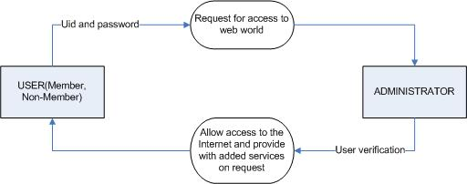

1 – LEVEL DFD
Here the previous level process is expanded and the working of the system is shown in details. This gives the steps involved n the process.

This shows the CLIENT SIDE level 1 dfd
- It shows how the user is categorized into two different category i.e. Member and Non-Member.
- It also provides knowledge about how the user gets login permission and allowed to access the internet.

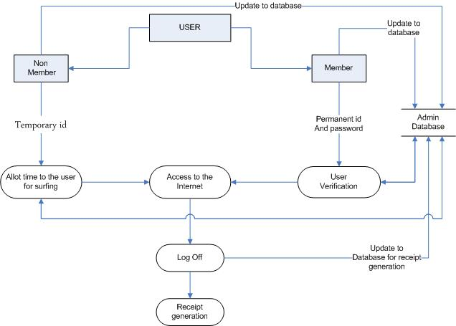

The following level 1 dfd shows the SERVER SIDE
- It shows how the administrator works.
- It shows how the user verification is done and also how new user entry is carried out.

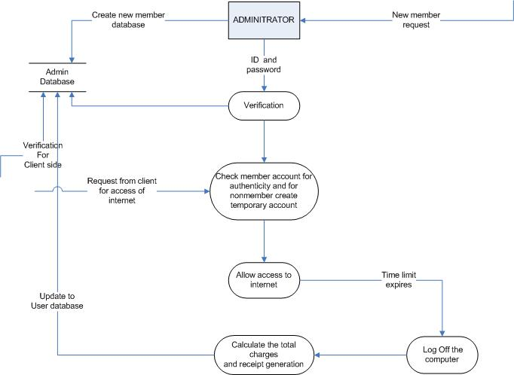

2 – LEVEL DFD
Here the whole systems working are shown in details. It can be said as glass box view in which the whole system is crystal clear. This is the final level of data flow diagram.
CLIENT SIDE DFD

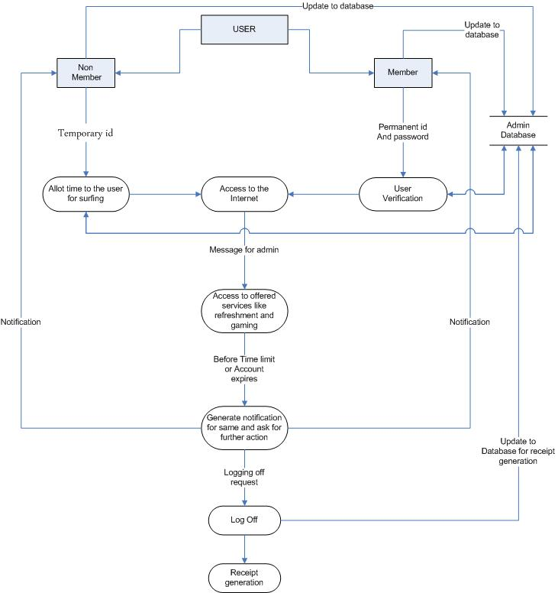

In CLIENT SIDE
- It shows the categorization of user and the procedure through which they can communicate with the administrator and request him to allow them to access the internet.
- According to type of user the administrator allow access to internet i.e. for prepaid user the time limit for web surfing is pre decided and after the limit expires the user is logged out from internet. And for post paid user the time limit is not decided, he himself logs out when needed. All the above information is recorded in the administrator database for any further use.
- Pre paid accounts are used for regular customer they are updated be the administrator according to the customer use.
- It also show how the and when the user can logout of internet and on what conditions the administrator logs him out.
- Receipt generation process is also shown in the following DFD.

SERVER SIDE DFD

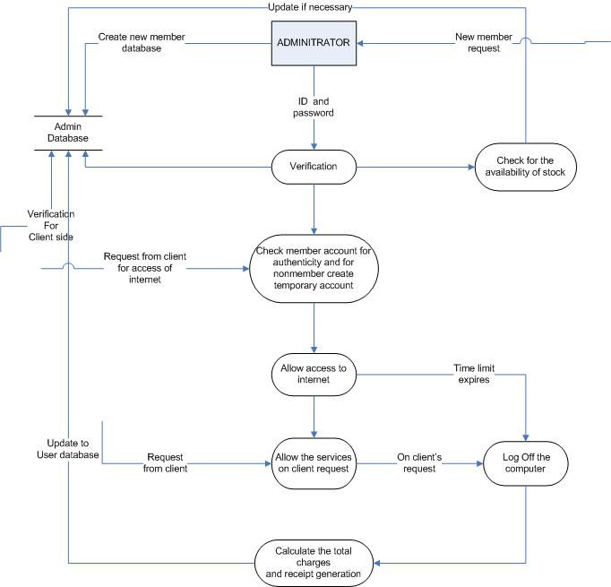

In SERVER SIDE

- It show the working and the responsibilities of the administrator.
- The main working of the administrator is the verification of the user and its category. He is also responsible for making updates regarding the particular user.
- According to type of user the administrator allow access to internet i.e. for prepaid user the time limit for web surfing is pre decided and after the limit expires the user is logged out from internet. And for post paid user the time limit is not decided, he himself logs out when needed. All the above information is recorded in the administrator database for any further use.
- Pre paid accounts are used for regular customer they are updated be the administrator according to the customer use.
- The administrator also generate receipt for each session, either a pre paid session or a post paid session.
- The administrator receives the messages from the user accessing the internet about their requirement such as floppy disk requirement, CDs
refreshments etc and he if possible tries to fulfil them.
- Report generation is also done by the administrator ,reports regarding the total usage of internet weekly or monthly and about the funds incurred in the extra services provided to user

USE CASE DIAGRAM

Use Case Diagram
A use case is a static description of some way in which a system or a business is used, by its customers, its users or by other systems. A use case diagram shows how system use cases are related to each other and how the users can get at them. Each bubble on a use case diagram represents a use case and each stick person represents a user.
The following use case diagram depicts the interaction between user , administrator and the modules of our application. This diagram has the following keywords which are described below.

- END :- This represents the nodes which are acting as an end point. Which may or may not be extended further.
- EXTENDS :- This keyword is used to show that which modules are extended further. Extended means to inherit some module to provide some additional features to the modules
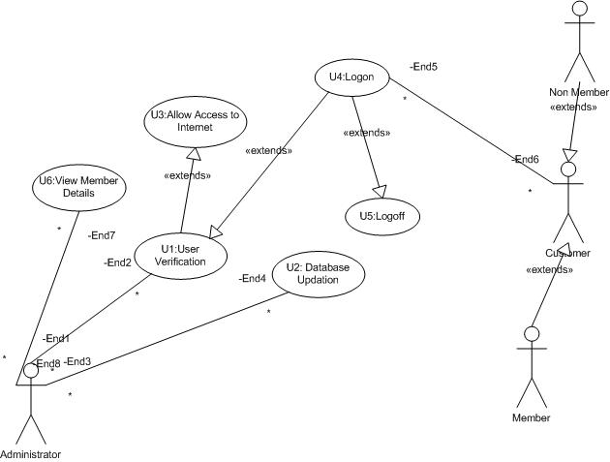

FORM DESIGN

SERVER SIDE

MAIN FORM

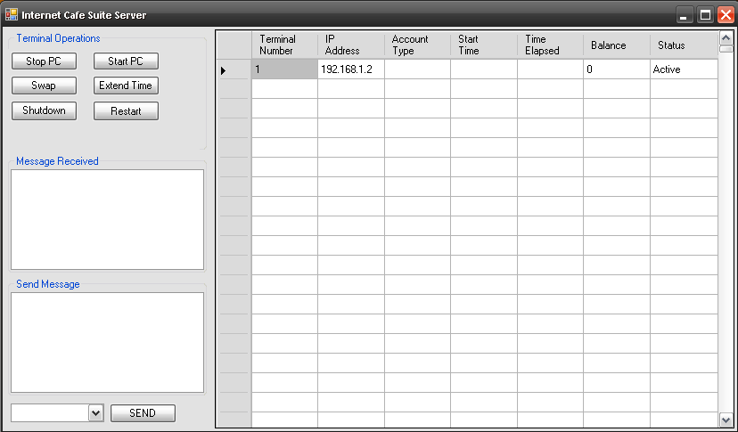

This is the main form of the server side application. This is a very easy to use , user friendly design , having a very professional look. Some internal features handled using this form is as follows:-

- STOP PC
- START PC
- SWAP
- EXTEND TIME
- SHUTDOWN
- RESTART
- SEND AND RECEIVE MESSAGE BETWEEN CLIENT AND SERVER

COMMODITY ITEMS

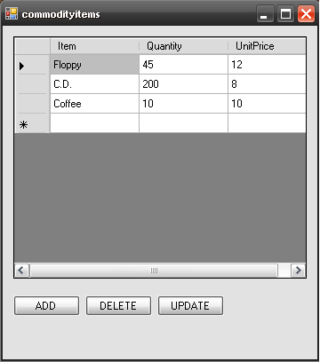

This form design is used to handle or manage the other commodity items which are manage in the application. This form shows the details regarding the following factors of a commodity.

- ITEM
- QUANTITY
- UNIT PRICE

CREATE ACCOUNT

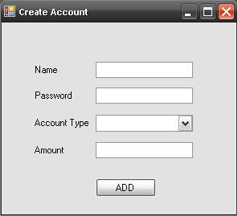

This form is used to create an instance of the user with its username, password, account type, amount paid in case of prepaid customer.

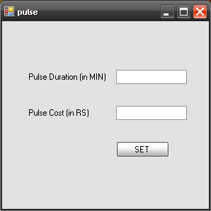
PULSE RATE

This form is used to setup the pulse rate of the applications cost management. Duration and pulse is set using this form.

CLIENT SIDE

MAIN FORM

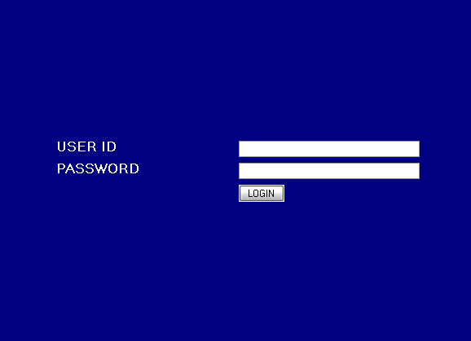

This is the form which locks the client screen. This screen is a special kind of form which locks the terminal of the client by doing the following operations.

- DISABLE TASKMANAGER.
- DISABLE “ALT+TAB” KEY COMBINATION
- DISABLE “ALT+ESC” KEY COMBINATION
- DISABLE “WIN KEY” KEY COMBINATION
- DISABLE “WIN+R” KEY COMBINATION

STATUS FORM

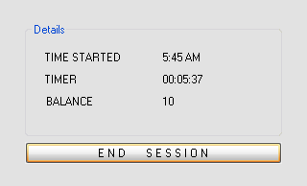

This form is used by the customer to view the status of his account and the time elapsed while using the service. This form is also used to end the session.

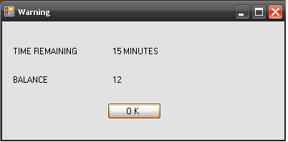
WARNING FORM

This form is used by the application itself to tell the customer that very less time is left.

DATABASE DESIGN

USER TABLE

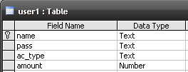

In this table the information about the users are present. Whenever the new user comes the inputs are done here only. Already existing users can login through client after validation through this table only.
The fields are described here

- NAME :- User name either existing or new.
- PASSWORD :- Password corresponding to the username.
- AC_TYPE :- Account type of the associated user.(Pre, Post)
- AMOUNT :- the amount deposited by the user if prepaid.

LOOKUP TABLE

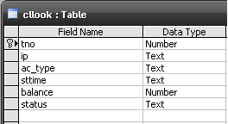

This table contains the information about the terminals during runtime. Status of every terminal is stored here in the server and the server side application grabs the data regarding the clients from here itself. The different fields of this table are described here below.

- TNO :- This represents the terminal number of the client.
- IP :- This represents the IP address of the terminal associated.
- AC_TYPE :- this represents the account type of the user associated with the terminal
- STTIME :- This represent the login time of the system.
- BALANCE :- This represents the remaining balance of the user.
- STATUS :- This represents the systems status.

COMMODITY TABLE

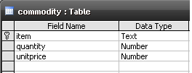

This table is used to store the other commodities which are offered by the internet café , its quantities and its unit price . this helps the café manager to easily manage the other commodities and provide them to the customer.
The fields in this table are described below.

- ITEM :- This represents the name of the item which is present in the café.
- QUANTITY :- This represents the quantity of the commodity item.
- UNIT PRICE :- This represents the unit price of the commodity.

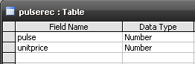
PULSE TABLE

This table is used to store the pulse timings and price per unit pulse. This table is used to calculate the deduction amount of the user .the fields are described below.

- PULSE :- This field stores the pulse time.
- UNIT PRICE :- This field stores the price of the unit pulse.

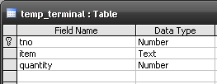
TEMPORARY TERMINAL TABLE

This table is used to temporarily store the data of a particular terminal if the terminals user purchases some item from the present commodities. This table is used in billing and receipt printing by the user. The fields are described below.

- TNO :- This field is used to store the terminal number which is currently logged in.
- ITEM :- This field is used to store the item which that terminal user has purchased.
- QUANTITY :- This field is used to store the quantity of that commodity purchased.

Chapter – 4

IMPLEMENTATION

4.1 Programming Approach

Once the design is complete, most of the major decisions about the system have been made. However, many of the details about coding the design, which often depend on the programming language chosen, are not specified during the design. The goal of the coding phase is to translate the design of the system into code in a given programming language.

The coding phase affects code can reduce the testing and maintenance profoundly well written code can reduce testing and maintenance effort. The goal of the coding is to reduce testing and maintenance effort because the testing and the maintenance costs of the software are much higher as compare to the coding cost.

- Coding is under taken once the design phase is completed and the design documents have been successfully reviewed.
- Every module is coded independently.
- A coding standard gives a uniform appearance to the codes written by different engineers.

- It provides sound understanding of the code & programming practices.
- Code review for a module is carried out after the successfully compiled and all the syntax error eliminated.
6. Objective of the coding phase is to transform the design of a system into high level language code.

4.2 CODING OF KEY INTERFACES

SERVER SIDE CODING

' ////THESE ARE IMPORTING THE REFERENCES FROM VARIOUS CLASSES//////////////////////////
Imports System.Net.Sockets
Imports System
Imports System.Net
Imports System.Text
Imports System.Data
Imports System.Data.OleDb
Imports ADODB

Public Class main

'//////////////////////////////////////VARIABLE DECLARATION/////////////////////////////////////////

Public terminalip As New List(Of String)
Dim row As Integer = 0
Public ipaddr() As IPAddress
Dim pu As Integer
Dim i As Integer = 0
Dim pup As Double
Public tno As String = ""
Dim ts As String
Dim cllisten, d As Threading.Thread
Dim con As New ADODB.Connection
Public comcmd1 As String()
Dim rd As New ADODB.Recordset
Public Shared Sub terminals(ByVal kno As Object)

End Sub

Private Sub main_FormClosing(ByVal sender As Object, ByVal e As System.Windows.Forms.FormClosingEventArgs) Handles Me.FormClosing
con.Close()

End Sub

Private Sub main_Load(ByVal sender As System.Object, ByVal e As System.EventArgs) Handles MyBase.Load

'///////////////////////////////////////////////////////////INITIALISING DATABASE CONNECTION/////////////////////
con.Open("Provider=Microsoft.Jet.OLEDB.4.0;Data Source=" & Application.StartupPath & "\mydb.mdb")

maingrid.Columns.Add("Terminal Number", "Terminal Number")
maingrid.Columns.Add("IP Address", "IP Address")
maingrid.Columns.Add("Account Type", "Account Type")
maingrid.Columns.Add("Start Time", "Start Time")
maingrid.Columns.Add("Time Elapsed", "Time Elapsed")
maingrid.Columns.Add("Balance", "Balance")
maingrid.Columns.Add("Status", "Status")
maingrid.Rows.Add(1000)
cllisten = New Threading.Thread(AddressOf clfunc)
tno = ";;"
comcmd1 = tno.Split(";")

'////////////////////////////////////////////starting client listener//////////////////////////////////////////////
cllisten.Start(Me)
Timer1.Start()

End Sub

Public Shared Sub clfunc(ByVal m As Object)
'///////////////////////////////////////////// COMMAND LISTENER <SERVER SIDE>///////////////////////////
While True
Dim tcpListener As New TcpListener(4000) 'on command port 8002
tcpListener.Start()
Dim cmd As String
Dim tcps As TcpClient = tcpListener.AcceptTcpClient()
Dim networkStream As NetworkStream = tcps.GetStream()
Dim requestS As String
Dim request(tcps.ReceiveBufferSize) As Byte
'''''''''''''''''''''''''''''''''READING COMMAND '''''''''''''''''''''''''''''''''''
'networkStream.ReadTimeout = 1000
networkStream.Read(request, 0, tcps.ReceiveBufferSize)
requestS = Encoding.ASCII.GetString(request) ' command for sending frames
m.comcmd1 = requestS.Split(";")
cmd = requestS.ToString
'm.tno = cmd.ToString
'MsgBox(cmd)
'networkStream.Write(request, 0, 3)
networkStream.Close()
tcps.Close()
tcpListener.Stop()
End While

End Sub

Private Sub Timer1_Tick(ByVal sender As System.Object, ByVal e As System.EventArgs) Handles Timer1.Tick
'If tno <> "" Then
' If Not terminalip.Contains(tno.ToString) Then
' maingrid.Rows.Add()
' maingrid.Item(0, row).Value = tno.Substring(0, 3).ToString
' 'maingrid.Item(0, row).Value = tno.ToString
' terminalip.Add(tno.ToString)
' row = row + 1
' tno = ""
' End If
'End If

'///////////////////////////////////////////taking command from client after every 1 milisecond.//////////////////
rd.Open("select * from pulserec", con, CursorTypeEnum.adOpenDynamic, LockTypeEnum.adLockOptimistic)
rd.MoveFirst()
pu = rd(0).Value
pup = rd(1).Value
rd.Close()
con.Close()
con.Open("Provider=Microsoft.Jet.OLEDB.4.0;Data Source=" & Application.StartupPath & "\mydb.mdb")
If comcmd1(0) <> "" Then
Select Case (comcmd1(0))

'///////////////////////////////////////connecting from client command/////////////////////////////////////////////
Case "clconnect"
rd.Open("select * from cllook", con, CursorTypeEnum.adOpenDynamic, LockTypeEnum.adLockOptimistic)
Try
rd.AddNew()
rd(0).Value = CInt(comcmd1(1).ToString())
rd(1).Value = comcmd1(2).ToString
rd(5).Value = comcmd1(3).ToString
rd.Update()
Catch ex As Exception
rd.CancelUpdate()
End Try
comcmd1(0) = ""
rd.Close()
con.Close()
con.Open("Provider=Microsoft.Jet.OLEDB.4.0;Data Source=" & Application.StartupPath & "\mydb.mdb")
rd.Open("select * from cllook", con, CursorTypeEnum.adOpenDynamic, LockTypeEnum.adLockOptimistic)
i = 0
rd.MoveFirst()
While rd.EOF <> True

maingrid.Item(0, i).Value = rd(0).Value
maingrid.Item(1, i).Value = rd(1).Value
maingrid.Item(2, i).Value = rd(2).Value
maingrid.Item(3, i).Value = rd(3).Value
'maingrid.Item(4, i).Value = rd(0).Value
maingrid.Item(5, i).Value = rd(4).Value
maingrid.Item(6, i).Value = rd(5).Value
rd.MoveNext()
i = i + 1
End While
rd.Close()

Return

'///////////////////////////////////////////////////////login command with client validation//////////////////////////////
Case "login"
rd.Open("select * from user1 where (name='" & comcmd1(1).ToString & "' and pass='" & comcmd1(2).ToString & "')", con, CursorTypeEnum.adOpenDynamic, LockTypeEnum.adLockOptimistic)

If rd.EOF = True Then

'///////////////////////////////////////////////////////////sending command///////////////////////////////////////////////////////
Try
Dim tcpClient2 As New System.Net.Sockets.TcpClient()
Dim sndcmd As String
tcpClient2.Connect(IPAddress.Parse(comcmd1(3).ToString), 4001) 'porC = 8002 bydefault
Dim networkStream2 As NetworkStream = tcpClient2.GetStream()
sndcmd = "login;0;"
Dim sndcmdB() As Byte = Encoding.ASCII.GetBytes(sndcmd)
networkStream2.Write(sndcmdB, 0, sndcmdB.Length) ' sending command
networkStream2.Close()
tcpClient2.Close()
Catch ex As Exception
comcmd1(0) = ""
rd.Close()
MsgBox(ex.Message)

End Try
comcmd1(0) = ""
Else
Try
Dim tcpClient2 As New System.Net.Sockets.TcpClient()
Dim sndcmd As String
tcpClient2.Connect(IPAddress.Parse(comcmd1(3).ToString), 4001) 'porC = 8002 bydefault
Dim networkStream2 As NetworkStream = tcpClient2.GetStream()
rd.MoveFirst()
sndcmd = "login;1;" & rd(2).Value & ";" & rd(3).Value & ";" & pu.ToString & ";" & pup.ToString & ";"
Dim sndcmdB() As Byte = Encoding.ASCII.GetBytes(sndcmd)
networkStream2.Write(sndcmdB, 0, sndcmdB.Length) ' sending command
networkStream2.Close()
tcpClient2.Close()
rd(3).Value = rd(3).Value - pup
rd.Update()
Catch ex As Exception
comcmd1(0) = ""
rd.Close()
MsgBox(ex.Message)

End Try
comcmd1(0) = ""
End If
rd.Close()
con.Close()
con.Open("Provider=Microsoft.Jet.OLEDB.4.0;Data Source=" & Application.StartupPath & "\mydb.mdb")
comcmd1(0) = ""
Return
End Select
End If
End Sub
End Class

CLIENT SIDE CODING

' ////////////////////////////THESE ARE IMPORTING THE REFERENCES FROM VARIOUS CLASSES//////////////////////////
Imports System
Imports System.Net
Imports System.Net.Sockets
Imports System.Text
Public Class mainlogin

'/////////////////////////////////////VARIABLE DECLARATION/////////////////////////////////////////

Dim WithEvents kbhook As New WindowsHookLib.LLKeyboardHook
Dim taskmgr_thread, clsend As Threading.Thread
Dim f As Boolean
Dim status As String
Dim ip As IPAddress()
Public cmd As String()
Dim ddd As String

Private Sub Button1_Click(ByVal sender As System.Object, ByVal e As System.EventArgs) Handles Button1.Click
End
End Sub

Private Sub Form1_Load(ByVal sender As System.Object, ByVal e As System.EventArgs) Handles MyBase.Load
taskmgr_thread = New Threading.Thread(AddressOf exec_thread)
clsend = New Threading.Thread(AddressOf clse)

'////////////////////////////////////////////starting taskmanager blocking thread/////////////////////////////////////
taskmgr_thread.Start()

'////////////////////////////////////////////starting command sender thread//////////////////////////////////////////
clsend.Start(Me)

Try
kbhook.InstallHook(True)
Catch ex As Exception
MsgBox(ex.Message.ToString)
End Try
Me.TopMost = True
Try
Dim tcpClient2 As New System.Net.Sockets.TcpClient()
Dim sndcmd As String
tcpClient2.Connect(IPAddress.Parse("127.0.0.1"), 4000) 'porC = 8002 bydefault
Dim networkStream2 As NetworkStream = tcpClient2.GetStream()
' sndcmd = s.substring(0, 3).ToString & Dns.GetHostAddresses(Dns.GetHostName).ToString & s.subString(3, 1)
ip = Dns.GetHostAddresses(Dns.GetHostName)
sndcmd = "clconnect;1;" & ip.GetValue(0).ToString & ";" & "Active;"
Dim sndcmdB() As Byte = Encoding.ASCII.GetBytes(sndcmd)
networkStream2.Write(sndcmdB, 0, sndcmdB.Length) ' sending command
networkStream2.Close()
tcpClient2.Close()

Catch ex As Exception
MsgBox(ex.Message)
End Try

ddd = ";;"
cmd = ddd.Split(";")
Timer1.Start()

End Sub

'/////////////////////////////BLOCKING KEY COMBINATIONS/////////////////////////////////////

Private Sub gkh_KeyDown(ByVal sender As Object, ByVal e As WindowsHookLib.KeyEventArgs) Handles kbhook.KeyDown
e.Handled = ((e.Modifiers = Keys.Alt AndAlso e.KeyCode = Keys.Escape) Or (e.Modifiers = Keys.Alt AndAlso e.KeyCode = Keys.F4) Or (e.Modifiers = Keys.Alt AndAlso e.KeyCode = Keys.Tab) Or (e.KeyCode = Keys.LWin) Or (e.KeyCode = Keys.RWin))
End Sub

Public Shared Sub exec_thread()
Application.Run(thread1)
mainlogin.TopMost = True
mainlogin.Focus()
End Sub

Public Shared Sub clse(ByVal s As Object)

'//////////////////////////////////////command listener/////////////////////////////////////////////////////
While True
Dim tcpListener As New TcpListener(4001) 'on command port 8002
tcpListener.Start()
'Dim cmd As String
Dim tcps As TcpClient = tcpListener.AcceptTcpClient()
Dim networkStream As NetworkStream = tcps.GetStream()
Dim requestS As String
Dim request(tcps.ReceiveBufferSize) As Byte
'''''''''''''''''''''''''''''''''READING COMMAND '''''''''''''''''''''''''''''''''''
'networkStream.ReadTimeout = 1000
networkStream.Read(request, 0, tcps.ReceiveBufferSize)
requestS = Encoding.ASCII.GetString(request) ' command for sending frames
s.cmd = requestS.Split(";")
'cmd = requestS.ToString
'm.tno = cmd.ToString
'MsgBox(cmd)
'networkStream.Write(request, 0, 3)
networkStream.Close()
tcps.Close()
tcpListener.Stop()
End While
End Sub

Private Sub Button2_Click(ByVal sender As System.Object, ByVal e As System.EventArgs)
End Sub

Private Sub TableLayoutPanel3_Paint(ByVal sender As System.Object, ByVal e As System.Windows.Forms.PaintEventArgs) Handles TableLayoutPanel3.Paint
End Sub

Private Sub Button3_Click(ByVal sender As System.Object, ByVal e As System.EventArgs) Handles Button3.Click

'///////////////////////////////////////////login command sender/////////////////////////////////////////
Try
Dim tcpClient2 As New System.Net.Sockets.TcpClient()
Dim sndcmd As String
tcpClient2.Connect(IPAddress.Parse("127.0.0.1"), 4000) 'porC = 8002 bydefault
Dim networkStream2 As NetworkStream = tcpClient2.GetStream()
' sndcmd = s.substring(0, 3).ToString & Dns.GetHostAddresses(Dns.GetHostName).ToString & s.subString(3, 1)
ip = Dns.GetHostAddresses(Dns.GetHostName)
sndcmd = "login;" & TextBox3.Text & ";" & TextBox4.Text & ";" & ip.GetValue(0).ToString & ";"
Dim sndcmdB() As Byte = Encoding.ASCII.GetBytes(sndcmd)
networkStream2.Write(sndcmdB, 0, sndcmdB.Length) ' sending command
networkStream2.Close()
tcpClient2.Close()

Catch ex As Exception
'INSERT LOGOFF CODE HERE////////////////////////////////////////////////////////////////////
MsgBox(ex.Message)
End Try
End Sub

Private Sub Timer1_Tick(ByVal sender As System.Object, ByVal e As System.EventArgs) Handles Timer1.Tick

'////////////////////////////////////////////////////////////////client validation result/////////////////////
If cmd(0) <> "" Then
Select Case cmd(0)
Case "login"
If cmd(1) = "0" Then
Label5.Text = "Wrong ID or Password"
ElseIf cmd(1) = "1" Then
'unlock()
Label5.Text = cmd(2) & " " & cmd(3) & " " & cmd(4)
End If
End Select
End If
End Sub

'////////////////////////////////unlock client terminal////////////////////////////////////////////////////////////
Public Sub unlock()
Me.Hide()
kbhook.RemoveHook(True)
Threading.Thread.Sleep(System.Threading.Timeout.Infinite)
End Sub

'//////////////////////////////////////////////lock client terminal///////////////////////////////////////////////
Public Sub lockscreen()
Me.Show()
kbhook.InstallHook(True)
taskmgr_thread.Resume()

End Sub
Public Sub calc_time(ByVal pulseunit As Double, ByVal mybal As Double)
If (mybal - pulseunit) < 0 Then
ElseIf (mybal - pulseunit) = 0 Then
Else

End If
End Sub
End Class

Public Class thread1
'/////////////////////////////////////////variable declaration////////////////////////////////////////////////////
Dim taskmgr As Process()
Dim instance As Process
Private Sub thread_Load(ByVal sender As System.Object, ByVal e As System.EventArgs) Handles MyBase.Load
Me.Hide()
Timer1.Start()
End Sub

'/////////////////////////////////////////////taask manager blocking thread coding////////////////////////
Private Sub Timer1_Tick(ByVal sender As System.Object, ByVal e As System.EventArgs) Handles Timer1.Tick
taskmgr = Process.GetProcessesByName("taskmgr")
For Each instance In taskmgr
instance.CloseMainWindow()
instance.Close()
Next
End Sub
End Class

Chapter – 5

TESTING

What is Software Testing???

Software testing is any activity aimed at evaluating an attribute or capability of a program or system and determining that it meets its required results. Although crucial to software quality and widely deployed by programmers and testers, software testing still remains an art, due to limited understanding of the principles of software. The difficulty in software testing stems from the complexity of software: we can not completely test a program with moderate complexity. Testing is more than just debugging. The purpose of testing can be quality assurance, verification and validation, or reliability estimation. Testing can be used as a generic metric as well. Correctness testing and reliability testing are two major areas of testing. Software testing is a trade-off between budget, time and quality.

TESTING STRATEGY

Software testing strategy includes the following:

- Test activities are determined and test data selected.
- The test is conducted and test results are compared with the expected results

There are various types of testing

Unit Testing

Unit Testing is essential for the verification of the code produced during the coding phase and the goal is test for the internal logic of the module/program. In the generic code project, the unit testing is done during coding phase of data entry forms whether the functions are working properly or not. In this phase all the drivers are tested, they are rightly connected or not.

Integration Testing

All the tested modules are combined into subsystems which are then tested. The goal is to see if the modules are properly integrated, and the emphasis being on the testing interfaces between the modules. In the generic code integration testing is done mainly on table creation module and insertion module.

System Testing

It is mainly used if the software meets its requirements. The reference document for this process is the requirement document.

Acceptance Testing

It is performed with realistic data of the client to demonstrate that the software is working satisfactorily. In the generic code project testing is done to check whether the creation of tables and respected data entry is working successfully or not.

TEST PLAN
Black-box testing
The black-box approach is a testing method in which test data are derived from the specified functional requirements without regard to the final program structure. It is also termed data-driven, input/output driven , or requirements-based testing. Because only the functionality of the software module is of concern, black-box testing also mainly refers to functional testing -- a testing method emphasized on executing the functions and examination of their input and output data. The tester treats the software under test as a black box -- only the inputs, outputs and specification are visible, and the functionality is determined by observing the outputs to corresponding inputs. In testing, various inputs are exercised and the outputs are compared against specification to validate the correctness. All test cases are derived from the specification. No implementation details of the code are considered.
It is obvious that the more we have covered in the input space, the more problems we will find and therefore we will be more confident about the quality of the software. Ideally we would be tempted to exhaustively test the input space. But as stated above, exhaustively testing the combinations of valid inputs will be impossible for most of the programs, let alone considering invalid inputs, timing, sequence, and resource variables. Combinatorial explosion is the major roadblock in functional testing. To make things worse, we can never be sure whether the specification is either correct or complete. Due to limitations of the language used in the specifications (usually natural language), ambiguity is often inevitable. Even if we use some type of formal or restricted language, we may still fail to write down all the possible cases in the specification. Sometimes, the specification itself becomes an intractable problem: it is not possible to specify precisely every situation that can be encountered using limited words. And people can seldom specify clearly what they want -- they usually can tell whether a prototype is, or is not, what they want after they have been finished. Specification problems contributes approximately 30 percent of all bugs in software.
The research in black-box testing mainly focuses on how to maximize the effectiveness of testing with minimum cost, usually the number of test cases. It is not possible to exhaust the input space, but it is possible to exhaustively test a subset of the input space. Partitioning is one of the common techniques. If we have partitioned the input space and assume all the input values in a partition is equivalent, then we only need to test one representative value in each partition to sufficiently cover the whole input space. Domain testing partitions the input domain into regions, and consider the input values in each domain an equivalent class. Domains can be exhaustively tested and covered by selecting a representative value(s) in each domain. Boundary values are of special interest. Experience shows that test cases that explore boundary conditions have a higher payoff than test cases that do not. Boundary value analysis requires one or more boundary values selected as representative test cases. The difficulties with domain testing are that incorrect domain definitions in the specification can not be efficiently discovered.
Good partitioning requires knowledge of the software structure. A good testing plan will not only contain black-box testing, but also white-box approaches, and combinations of the two.

White-box testing

Contrary to black-box testing, software is viewed as a white-box, or glass-box in white-box testing, as the structure and flow of the software under test are visible to the tester. Testing plans are made according to the details of the software implementation, such as programming language, logic, and styles. Test cases are derived from the program structure. White-box testing is also called glass-box testing, logic-driven testing or design-based testing .
There are many techniques available in white-box testing, because the problem of intractability is eased by specific knowledge and attention on the structure of the software under test. The intention of exhausting some aspect of the software is still strong in white-box testing, and some degree of exhaustion can be achieved, such as executing each line of code at least once (statement coverage), traverse every branch statements (branch coverage), or cover all the possible combinations of true and false condition predicates (Multiple condition coverage).
Control-flow testing, loop testing, and data-flow testing, all maps the corresponding flow structure of the software into a directed graph. Test cases are carefully selected based on the criterion that all the nodes or paths are covered or traversed at least once. By doing so we may discover unnecessary "dead" code -- code that is of no use, or never get executed at all, which can not be discovered by functional testing.
In mutation testing, the original program code is perturbed and many mutated programs are created, each contains one fault. Each faulty version of the program is called a mutant. Test data are selected based on the effectiveness of failing the mutants. The more mutants a test case can kill, the better the test case is considered. The problem with mutation testing is that it is too computationally expensive to use. The boundary between black-box approach and white-box approach is not clear-cut. Many testing strategies mentioned above, may not be safely classified into black-box testing or white-box testing. It is also true for transaction-flow testing, syntax testing, finite-state testing, and many other testing strategies not discussed in this text. One reason is that all the above techniques will need some knowledge of the specification of the software under test. Another reason is that the idea of specification itself is broad -- it may contain any requirement including the structure, programming language, and programming style as part of the specification content.
We may be reluctant to consider random testing as a testing technique. The test case selection is simple and straightforward: they are randomly chosen. Study in indicates that random testing is more cost effective for many programs. Some very subtle errors can be discovered with low cost. And it is also not inferior in coverage than other carefully designed testing techniques. One can also obtain reliability estimate using random testing results based on operational profiles. Effectively combining random testing with other testing techniques may yield more powerful and cost-effective testing strategies.

Performance testing
Not all software systems have specifications on performance explicitly. But every system will have implicit performance requirements. The software should not take infinite time or infinite resource to execute. "Performance bugs" sometimes are used to refer to those design problems in software that cause the system performance to degrade.
Performance has always been a great concern and a driving force of computer evolution. Performance evaluation of a software system usually includes: resource usage, throughput, stimulus-response time and queue lengths detailing the average or maximum number of tasks waiting to be serviced by selected resources. Typical resources that need to be considered include network bandwidth requirements, CPU cycles, disk space, disk access operations, and memory usage . The goal of performance testing can be performance bottleneck identification, performance comparison and evaluation, etc. The typical method of doing performance testing is using a benchmark -- a program, workload or trace designed to be representative of the typical system usage.
TEST CASES DESIGN

Following list is created while designing test cases :-
- A list of specific states of an object on which the tests are to be performed is created.
- Messages and Operations that will be involved during the test are listed.
- The expected exceptions that may be encountered during performing the tests are listed.
- A list indicating all the possible tests and their expected results is created to guide the testing process.
- Following are the types of test case design strategies :-

- Fault Based Testing strategy
- Here the tester looks for possible errors in the design and coding.
- The test cases are so designed that it would force an incorrect code to fail and would result an error-full output.
- Here the major errors to be identified are:-
Unexpected results.
Wrong operation invoked during message passing.

- Scenario Based Testing strategy
- Its done by deriving test cases from the user actions.
- The possible user actions are called scenarios.
- The user actions are identified and all possible tasks are preformed that an authorized as well as an unauthorized user can do on the system.

- Surface and Deep Structure Testing strategy
- In Surface testing the overall structure or overall working of the system is tested from user point of view. Its similar to Scenario based testing.
- Deep structure testing is concerned with testing the internal structure of the system, like testing the code, dependencies, behavior, etc.

POINT OF SALE SYSTEM

TC ID | TEST CASE | VALIDATION | TEST DATA | EXPECTED RESULT | ACTUAL RESULT
1 | Check item code for data validation | Should allow entry to data(A-Z,a-z,’-‘,’_’,0-9) | Enter (‘@’) | Should not accept
 |  | Should allow entry to data(A-Z, a-z,’-‘,’_’,0-9) | Enter (‘_’) | Should accept
2 | Check item name for data validation | Should allow entry to data(A-Z, a-z,’-‘,’_’) | Enter(1) | Should not accept
 |  | Should allow entry to data(A-Z, a-z,’-‘,’_’) | Enter(CD) | Should accept
3 | Check quantity for data validation | Should allow entry to data(0-9) | Enter(a) | Should not accept
 |  | Should allow entry to data(0-9) | Enter(11) | Should accept
4 | Check price for data validation | Should allow entry to data(0-9, ‘.’) | Enter(.) | Should accept
 |  | Should allow entry to data(0-9, ‘.’) | Enter(1.1) | Should accept
5 | Check connection for data query | Client should check connection from server before querying | Query for product without check | Will not work sometimes if connection is not present
 |  | Client should check connection from server before querying | Query for product after check | Will work always

RECEIPT SETUP

TC ID | TEST CASE | VALIDATION | TEST DATA | EXPECTED RESULT | ACTUAL RESULT
1 | Check for proper page size setup | Actual paper size should match setup size | Print with different page size than actual | Not a proper print out
 |  | Actual paper size should match setup size | Print with proper setup | Proper print out

MODES OF USING COMPUTER

TC ID | TEST CASE | VALIDATION | TEST DATA | EXPECTED RESULT | ACTUAL RESULT
1 | Check for type of session usage | Postpaid session | Login(uid, pwd) without paying | Allow login
 |  | Prepaid session | Login(uid, pwd) without paying | Don’t allow login
 |  | Prepaid session | Login(uid, pwd) after paying | Allow login
 |  | Prepaid account | Login(uid, pwd) without sufficient balance | Don’t allow login
 |  | Prepaid account | Login(uid, pwd) with sufficient balance | Allow login

PRINT MONITORING

TC ID | TEST CASE | VALIDATION | TEST DATA | EXPECTED RESULT | ACTUAL RESULT
1 | Check for print type | B/W page | Charge for color page | Don’t allow
 |  | B/W page | Charge for B/W page | Allow
 |  | Color page | Charge for B/W page | Don’t allow
 |  | Color page | Charge for color page | Allow
REMOTE CLIENT SETUP AND APPLICATION SETUP

TC ID | TEST CASE | VALIDATION | TEST DATA | EXPECTED RESULT | ACTUAL RESULT
1 | Check for clients setup | Check for activeness | Setup execution if not active | Don’t allow
 |  | Check for activeness | Setup execution if active | Allow
2 | Check for clients application setup | Check for presence of application | Setup application without its presence | Don’t allow
 |  | Check for presence of application | Setup application with its presence | Allow
 |  | Check for presence of application | Setup application if not active | Don’t allow
 |  | Check for presence of application | Setup application if active | Allow

TRANSFER SESSIONS

TC ID | TEST CASE | VALIDATION | TEST DATA | EXPECTED RESULT | ACTUAL RESULT
1 | Check for transfer of session | Check for activeness of terminals | Transfer session from PC1 to PC2 if PC2 is inactive | Don’t allow
 |  | Check for activeness of terminals | Transfer session from PC1 to PC2 if PC2 is active | Allow
 |  | Check for usage for terminals | Transfer session from PC1 to PC2 if PC2 is in use | Don’t allow
 |  | Check for usage for terminals | Transfer session from PC1 to PC2 if PC2 is free | Allow

SHUTDOWN OR REBOOT PCS

TC ID | TEST CASE | VALIDATION | TEST DATA | EXPECTED RESULT | ACTUAL RESULT
1 | Check for shutdown and reboot | Check for terminal activeness | Shutdown if inactive or free | Allow
 |  | Check for terminal activeness | Shutdown if active or in use | Give warning before action

TC ID | TEST CASE | VALIDATION | TEST DATA | EXPECTED RESULT | ACTUAL RESULT
1 | Check for ending session | Postpaid usage | Try to End session | Allow but after giving warning
 |  | Prepaid usage | Try to End session having enough balance | Allow but after giving warning
 |  | Prepaid usage | Try to End session even not having balance | Allow but after giving warning

END SESSIONS FROM SERVER

Chapter - 6
CONCLUSION

ADVANTAGES:-

Features of Internet Café Suite:
Internet Café Suite is technically sophisticated yet simple cyber cafe software to use. You can see that the features list of this superior cybercafe software is truly impressive. Employ this internet cafe software and gain total control over your cyber cafe operations.
Internet Café Suite has two user interfaces. One is the Server (Administrator) module and other is the Client Module. Internet Café Suite is compatible with Windows ME, NT, 2K, XP.

Using the Client Module (Customer Interface):
1) Login either as a member or a walk-in customer. The client module will freeze the usage of any other application till the user has logged in.
2) Order services like coffee/printing, which will automatically be added to his bill.
3) See his bill at any time during surfing.
4) Send any message to the administrator. Log off.

Using the Server Module (Admin Interface):
The easy to use interface of Internet Café Suite makes it possible for a person with no technical expertise to create and manage all the operations of cyber (internet) café. Given below are the powerful and useful features of Internet Café Suite.

Automatic Billing & Printing:
Generates automatic customer billing as soon as the customer logs off including browsing charges, printing charge, floppy charges, and tea coffee snacks charges. Print the bill as per customers demand.

Business Analyzer:
Keep a track of all the ‘In Use’ and ‘Free’ machines along with total billing on a daily basis. See exhaustive and flexible reports (any grouping and any filter), which can be copied to Excel. You customize reports to your requirements and save it as a template for future use.

Shift User Machine:
In case a machine hangs or some error occurs you can shift the customer to another machine and at the same time details of the customer along with his billing information are also transferred. Log off, shut down or restart any PC.

Banned Keyword Master:
Restrict access to unwanted sites using the Keyword Master. You can ban sites having specific keywords in their URL.

Earnings and Expenses:
Maintain records of all your business transactions. Check all the cash inflow and outflow. Record all the expenses and get earnings reports. It will help you in calculation of net profit for any given time and per machine too. This will help to get an approximate P/L a/c for any period.

Machine Master:
You can add all the machines on the LAN to WebCafe software. You can also add only selected systems in your café. Browse or search the LAN and add all or any of the machines to WebCafe or Internet Billing software
.
Create Categories:
You can categorize your members under different pricing schemes. For example, one category can be students, which can be offered a specified discount. This can boost usage time by students, which form a major category of the cyber (internet) café industry.

Create/Modify User Accounts:
Keep track of all your members and forward receipts. Create and modify user information, like password, category, expiry date, minimum balance etc.

Set Time Slots, Rates:
Option of setting different rates for Peak hours/ Happy hours on a 24-hour cycle. Set rates for additional services like printout, floppy, tea, coffee that would be added to final billing of the customer.

Chat with Customer / Manage Graffiti:
You can flash a message to any customer and chat with him. The customer can also send across a message if he needs any help or additional services. Make a customer message board where customers can post their messages and suggestions about the service.

Other Features are:
Close Client Module: Terminate customer session in the middle.
Lock Server Module: Lock the server to prevent any malfunctioning in your absence.
Change Transaction Date: Change date of server module as per your requirements.
Daily Transaction Report: Get a daily report of all your earnings
Expenses Report: Get details of all your expenses
Member Advance / Balance Report: Keep a track of all forward receipts and balance of member

LIMITATION
The only disadvantage is that it is expensive to install the first time but looking into the future scope the amount paid can be neglected to some extent.

FUTURE ENHANCEMENTS:
As the increase in the retail market, many high-tech applications and equipments are used where our software is very good option to use.

REFERENCES

MSDN.MICROSOFT.COM
THE COMPLETE REFERENCE [VB.NET]
PC WORLD FORUMS

